Break Even chart

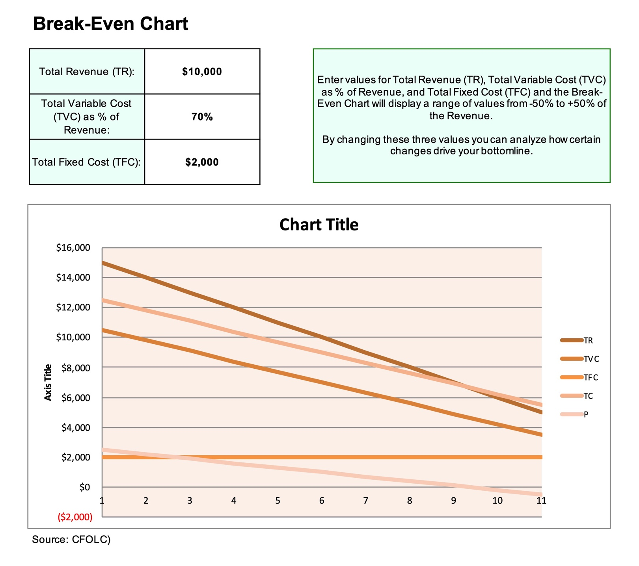

A break-even chart can help with your analysis to determine how many units you need to sell to cover costs and when a product or service is profitable.
CFOLC TOOLS LIBRARY

