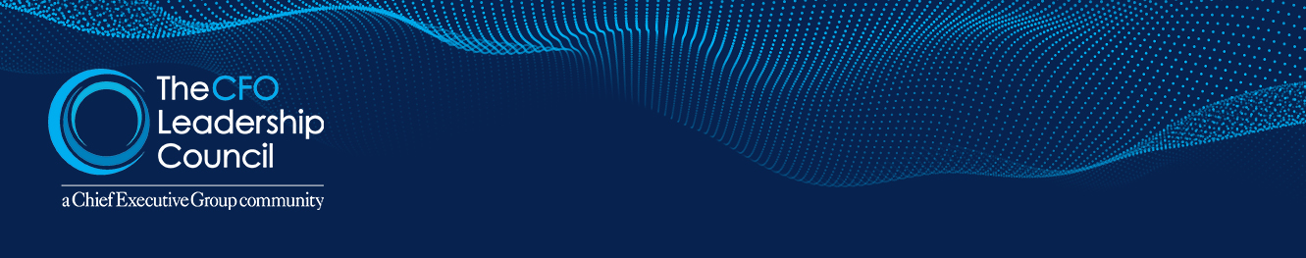
CFOLC TOOLS LIBRARY
New System for Zero-Base Budgeting

It’s no simple task to evaluate all expenditures as if there were no pre-existing practices. This process document provides direction.
Zero-based budgeting is a very important management process. Its logic, on its face, is very sensible: all expenditures should be evaluated as if there were no pre-existing practices. I think of this as the “if I could only wave a magic wand” approach to business.
The problem with this seemingly obvious approach is that it is almost impossible for managers to penetrate below the surface business procedures to examine and question the more fundamental “way we do business.” Managers almost always get so stuck in their traditional way of doing things that they are unable to carry out the objectives of zero-based budgeting. Hence, they fall back on tuning up existing practices for small incremental gains.
- EPM Breaks the Mold
Enterprise Profit Management (EPM) is the key to seeing clearly your company’s tacit set of business practices in order to take a real zero-based look at your company. EPM creates a full, all-in P&L for every transaction (every product bought by every customer every time) and uses a sophisticated data structure to combine and recombine these transactions to show the actual all-in profitability of every nook and cranny of a company.
Virtually all companies have a characteristic pattern of profit segmentation:
- Profit Peak Customers—typically about 20% of the customers generate 150% of a company’s profits;
- Profit Drain Customers—typically about 30% of the customers erode about 50% of these profits; and
- Profit Desert Customers—typically the remainder of the customers produce minimal profit but consume about 50% of a company’s resources
.
EPM gives a crystal-clear picture of your company at a very granular level. It identifies where re-thinking and resetting a company’s “way of doing business” is most needed. This enables you to analyze exactly where your company is making money, where it is experiencing Profit Drains, why this is happening and what to do to accelerate the Profit Peaks, reduce or reverse the Profit Drains and increase the profitability of your Profit Deserts.
Every company is an “accidental company” in the sense that it is built to a surprising extent from old business practices. In our research and work with Profit Isle clients, we’ve found in industry after industry that even in leading companies Enterprise Profit Management’s zero-based look enables managers to increase their profitability by 10-30% per year sustainably.
- Why Does This Occur in So Many Companies?
This situation occurs in company after company because in our prior Age of Mass Markets, profitability was a function primarily of sales volume, which created economies of scale in everything from production to distribution to advertising. Prices were set by manufacturers, and distribution costs were very homogeneous because products were simply delivered to the customers’ receiving docks.
In the past 30 years, we have moved into what I call the Age of Diverse Markets, in which everything changed. Prices are negotiated, and often vary by account and product. Costs also vary widely, as suppliers form very different relationships—ranging from arm’s length to highly integrated—with their customers. Industry boundaries are blurring, and capable new competitors are seizing market share.
In this new environment, markets are segmenting rapidly, and success or failure rides on a manager’s ability to deeply understand where his or her company is making all its profits, to assess whether this segment is adequately differentiated and protected, and to channel the company’s resources into the market segments with high sustainable profits. In short, the company must cut loose from the sea anchor of its history and build its future with a real zero-based process. Enterprise Profit Management is the only way to accomplish this life-or-death objective.
Today, the traditional broad accounting categories of revenues and costs, which worked so well in the prior era and which still work well for financial reporting, are completely inadequate for understanding granular profitability. Yet we continue to manage as if we still live in the prior era.
What you get is the familiar pattern of “islands of profit in a sea of red ink” that is the vestige of doing business in a way that worked years ago, but no longer fits—just like hiccups and sitting on the sides of an auditorium.
- The Power of Enterprise Profit Management
The power of Enterprise Profit Management is that it yields an extremely powerful view of the company as it really is today—where it is working, where it is not and why.
When you see this very granular picture of your company’s profit landscape, you will immediately realize where your company’s activities—its “way of doing business”—fit today’s business needs, and where they are deficient because they are essentially continuing to apply old ways of doing business that are vestiges of the past and no longer appropriate.
With this detailed profit picture, you can’t help but take a real zero-based look at your company. You will be able to develop a sound step-by-step plan to bring your “way of doing business” into alignment with today’s business needs. This is where the really big money is.
- New Profitability
Enterprise Profit Management SaaS systems can be configured in a few weeks. They are extremely timely and accurate because the information is drawn directly from a company’s general ledger. Because the zero-based actions they enable are rooted in an intuitively clear, granular profit picture, you can be confident that they will be accepted and work.

(Source: CFOLC)

