
Automation Benchmarking Report
CFOLC TOOLS LIBRARY
CFOLC TOOLS LIBRARY

The move to full digital transformation is not around the corner for most CFOs. But the process has begun.
This key report shows what companies are doing now to plan for the future. Where do you stand in the hunt?
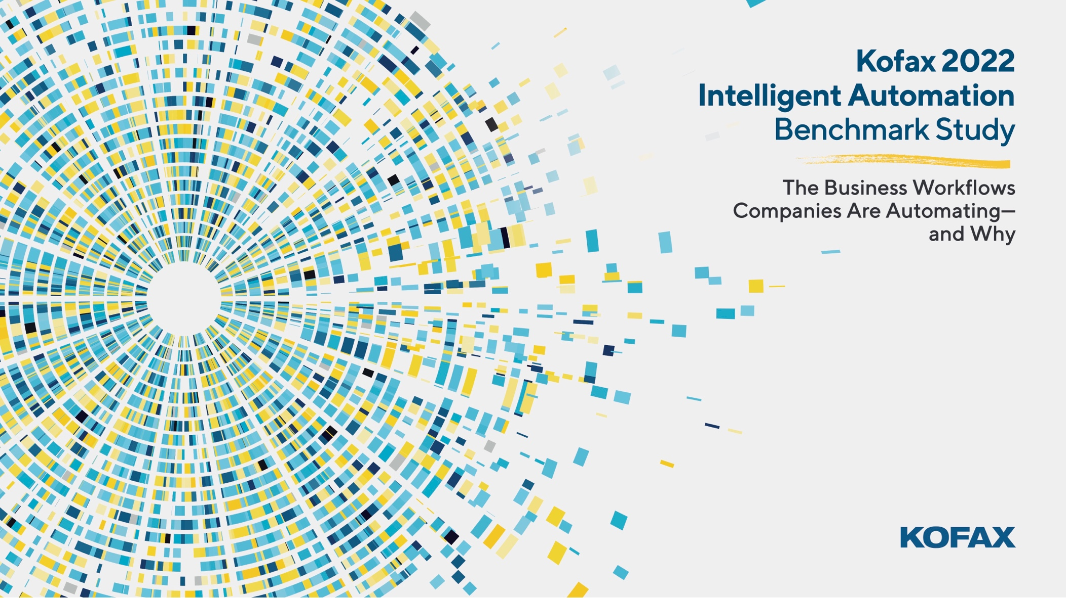

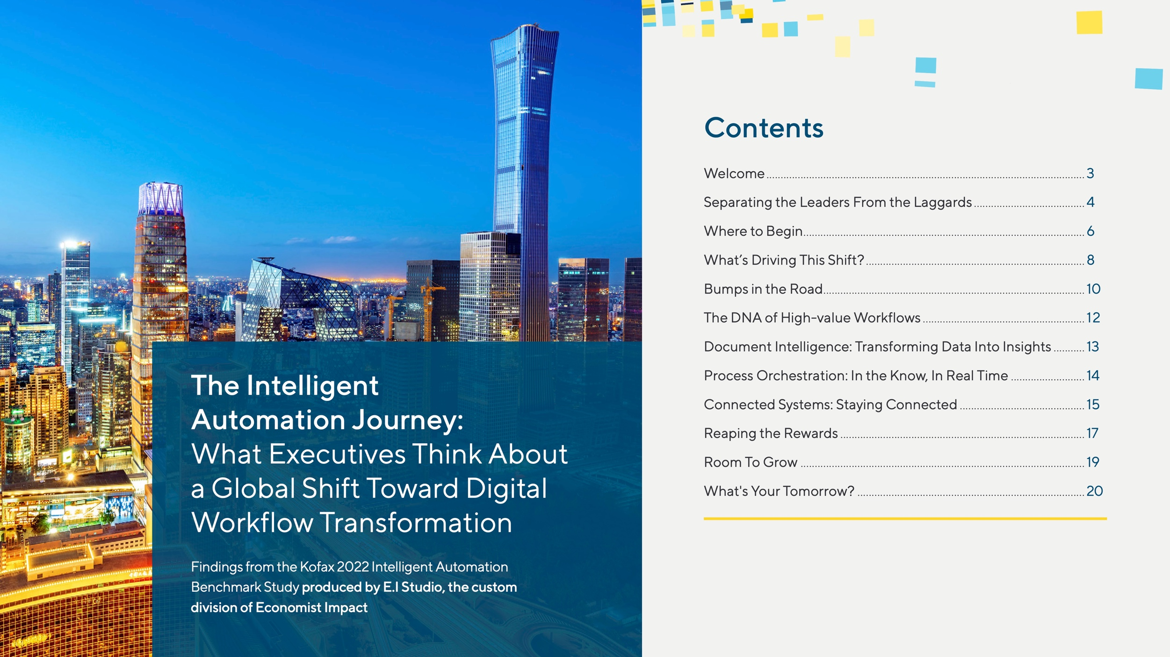

The Intelligent Automation Journey:

What Executives Think About a Global Shift

Toward Digital Workflow Transformation 




Kathleen Delaney
Kofax Chief Marketing Officer
Findings from the Kofax 2022
Intelligent Automation Benchmark Study

First published in 2019, this yearly report has become the insider study detailing companies’ intelligent automation ambitions, challenges and outcomes.
In our pre-Covid, 2020–21 Kofax Intelligent Automation Benchmark Study,* enterprise executives surveyed confirmed their focus on intelligent automation. Growth of intelligent automation budgets was projected at more than 40% and the technology approach companies were taking to automate was just as important. Executives said taking
a multi-vendor, point-solution approach to automation created challenges including technical debt (46%), delays in successful outcomes (35%) and lower ROI (33%). Almost all respondents (99%) preferred a single-vendor, platform approach—citing improved customer experience (54%), employee productivity
(52%), efficiency (52%) and
security/compliance (51%) as benefits of integrated intelligent automation platforms. In addition, 48% of respondents said their employees lacked technical skills to navigate their automation technology, and therefore they preferred a low-code platform that was easy to use (80%) yet advanced enough for technical power users (78%).
This year, as organizations are navigating a drastically altered business landscape, 800 respondents share that their companies face myriad new challenges, from supply-
chain disruptions to workforce shortages. At a moment when virtually all companies agree that intelligent automation will help them overcome these challenges, questions abound about where to focus their priorities.
So, what types of automation yield the greatest benefit to enterprises around the world? Read on to find out.


- | Kofax 2022 Intelligent Automation Benchmark Study * A series of three commissioned thought leadership reports developed from a study conducted by Forrester Consulting on behalf of Kofax, January 2020

end-to-end digital transformation



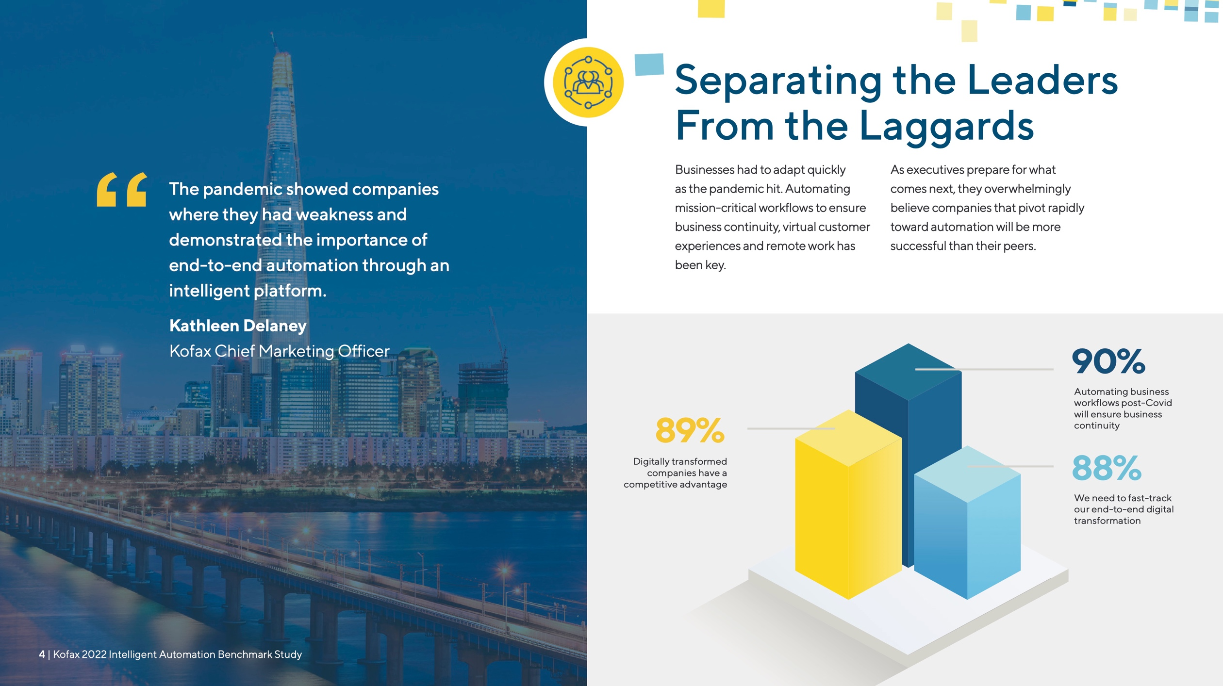




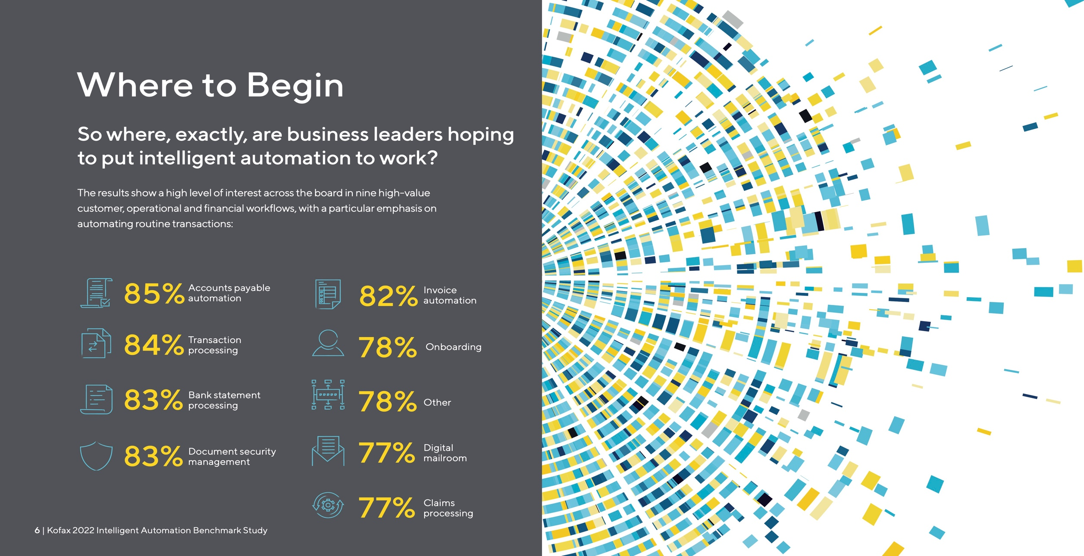

Where to Begin

So where, exactly, are business leaders hoping to put intelligent automation to work?

The results show a high level of interest across the board in nine high-value customer, operational and financial workflows, with a particular emphasis on automating routine transactions:

Digital mailroom

Claims processing

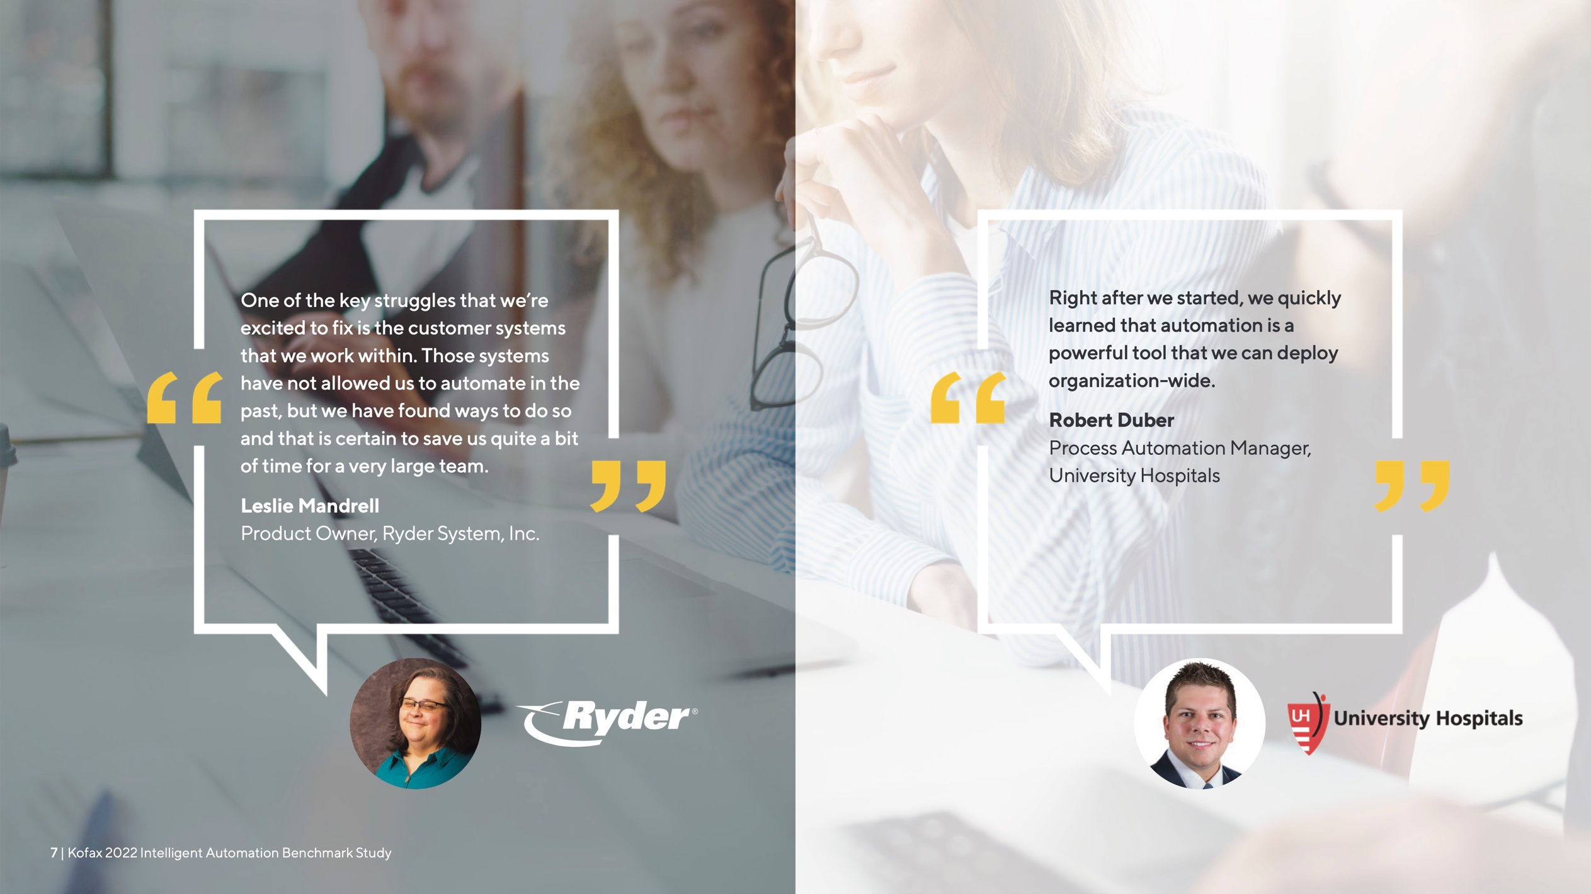

One of the key struggles that we’re excited to fix is the customer systems that we work within. Those systems have not allowed us to automate in the past, but we have found ways to do so and that is certain to save us quite a bit of time for a very large team.



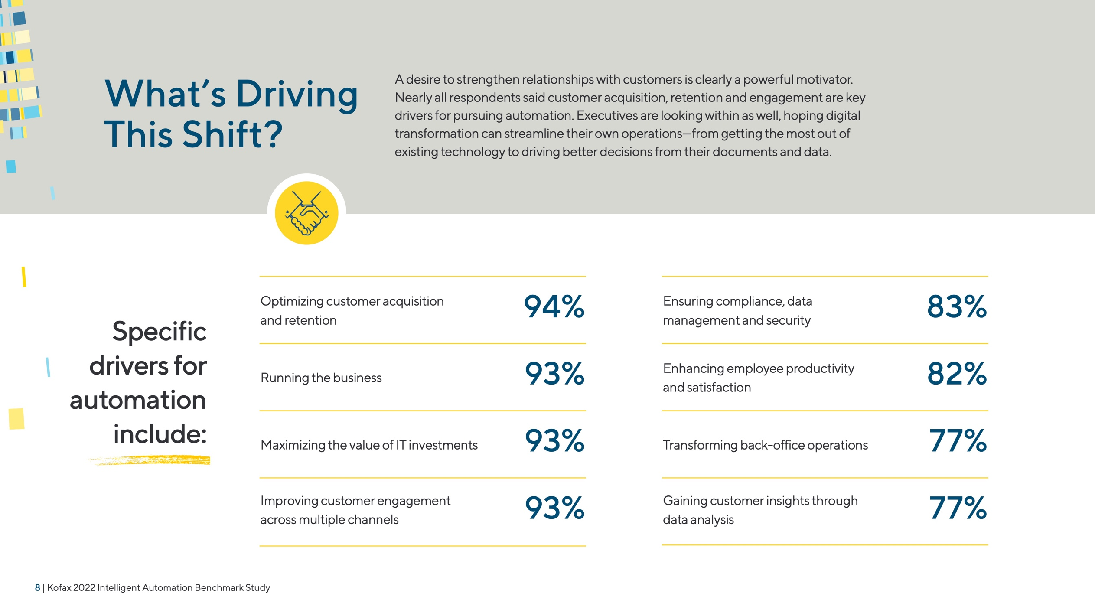

What’s Driving This Shift?

A desire to strengthen relationships with customers is clearly a powerful motivator. Nearly all respondents said customer acquisition, retention and engagement are key drivers for pursuing automation. Executives are looking within as well, hoping digital transformation can streamline their own operations—from getting the most out of existing technology to driving better decisions from their documents and data.

Specific drivers for automation
include:
Optimizing customer acquisition and retention

Running the business

Maximizing the value of IT investments

Improving customer engagement across multiple channels
94%
93%
93%
93%
Ensuring compliance, data management and security

Enhancing employee productivity and satisfaction

Transforming back-office operations

Gaining customer insights through data analysis
83%
82%
77%
77%



- | Kofax 2022 Intelligent Automation Benchmark Study

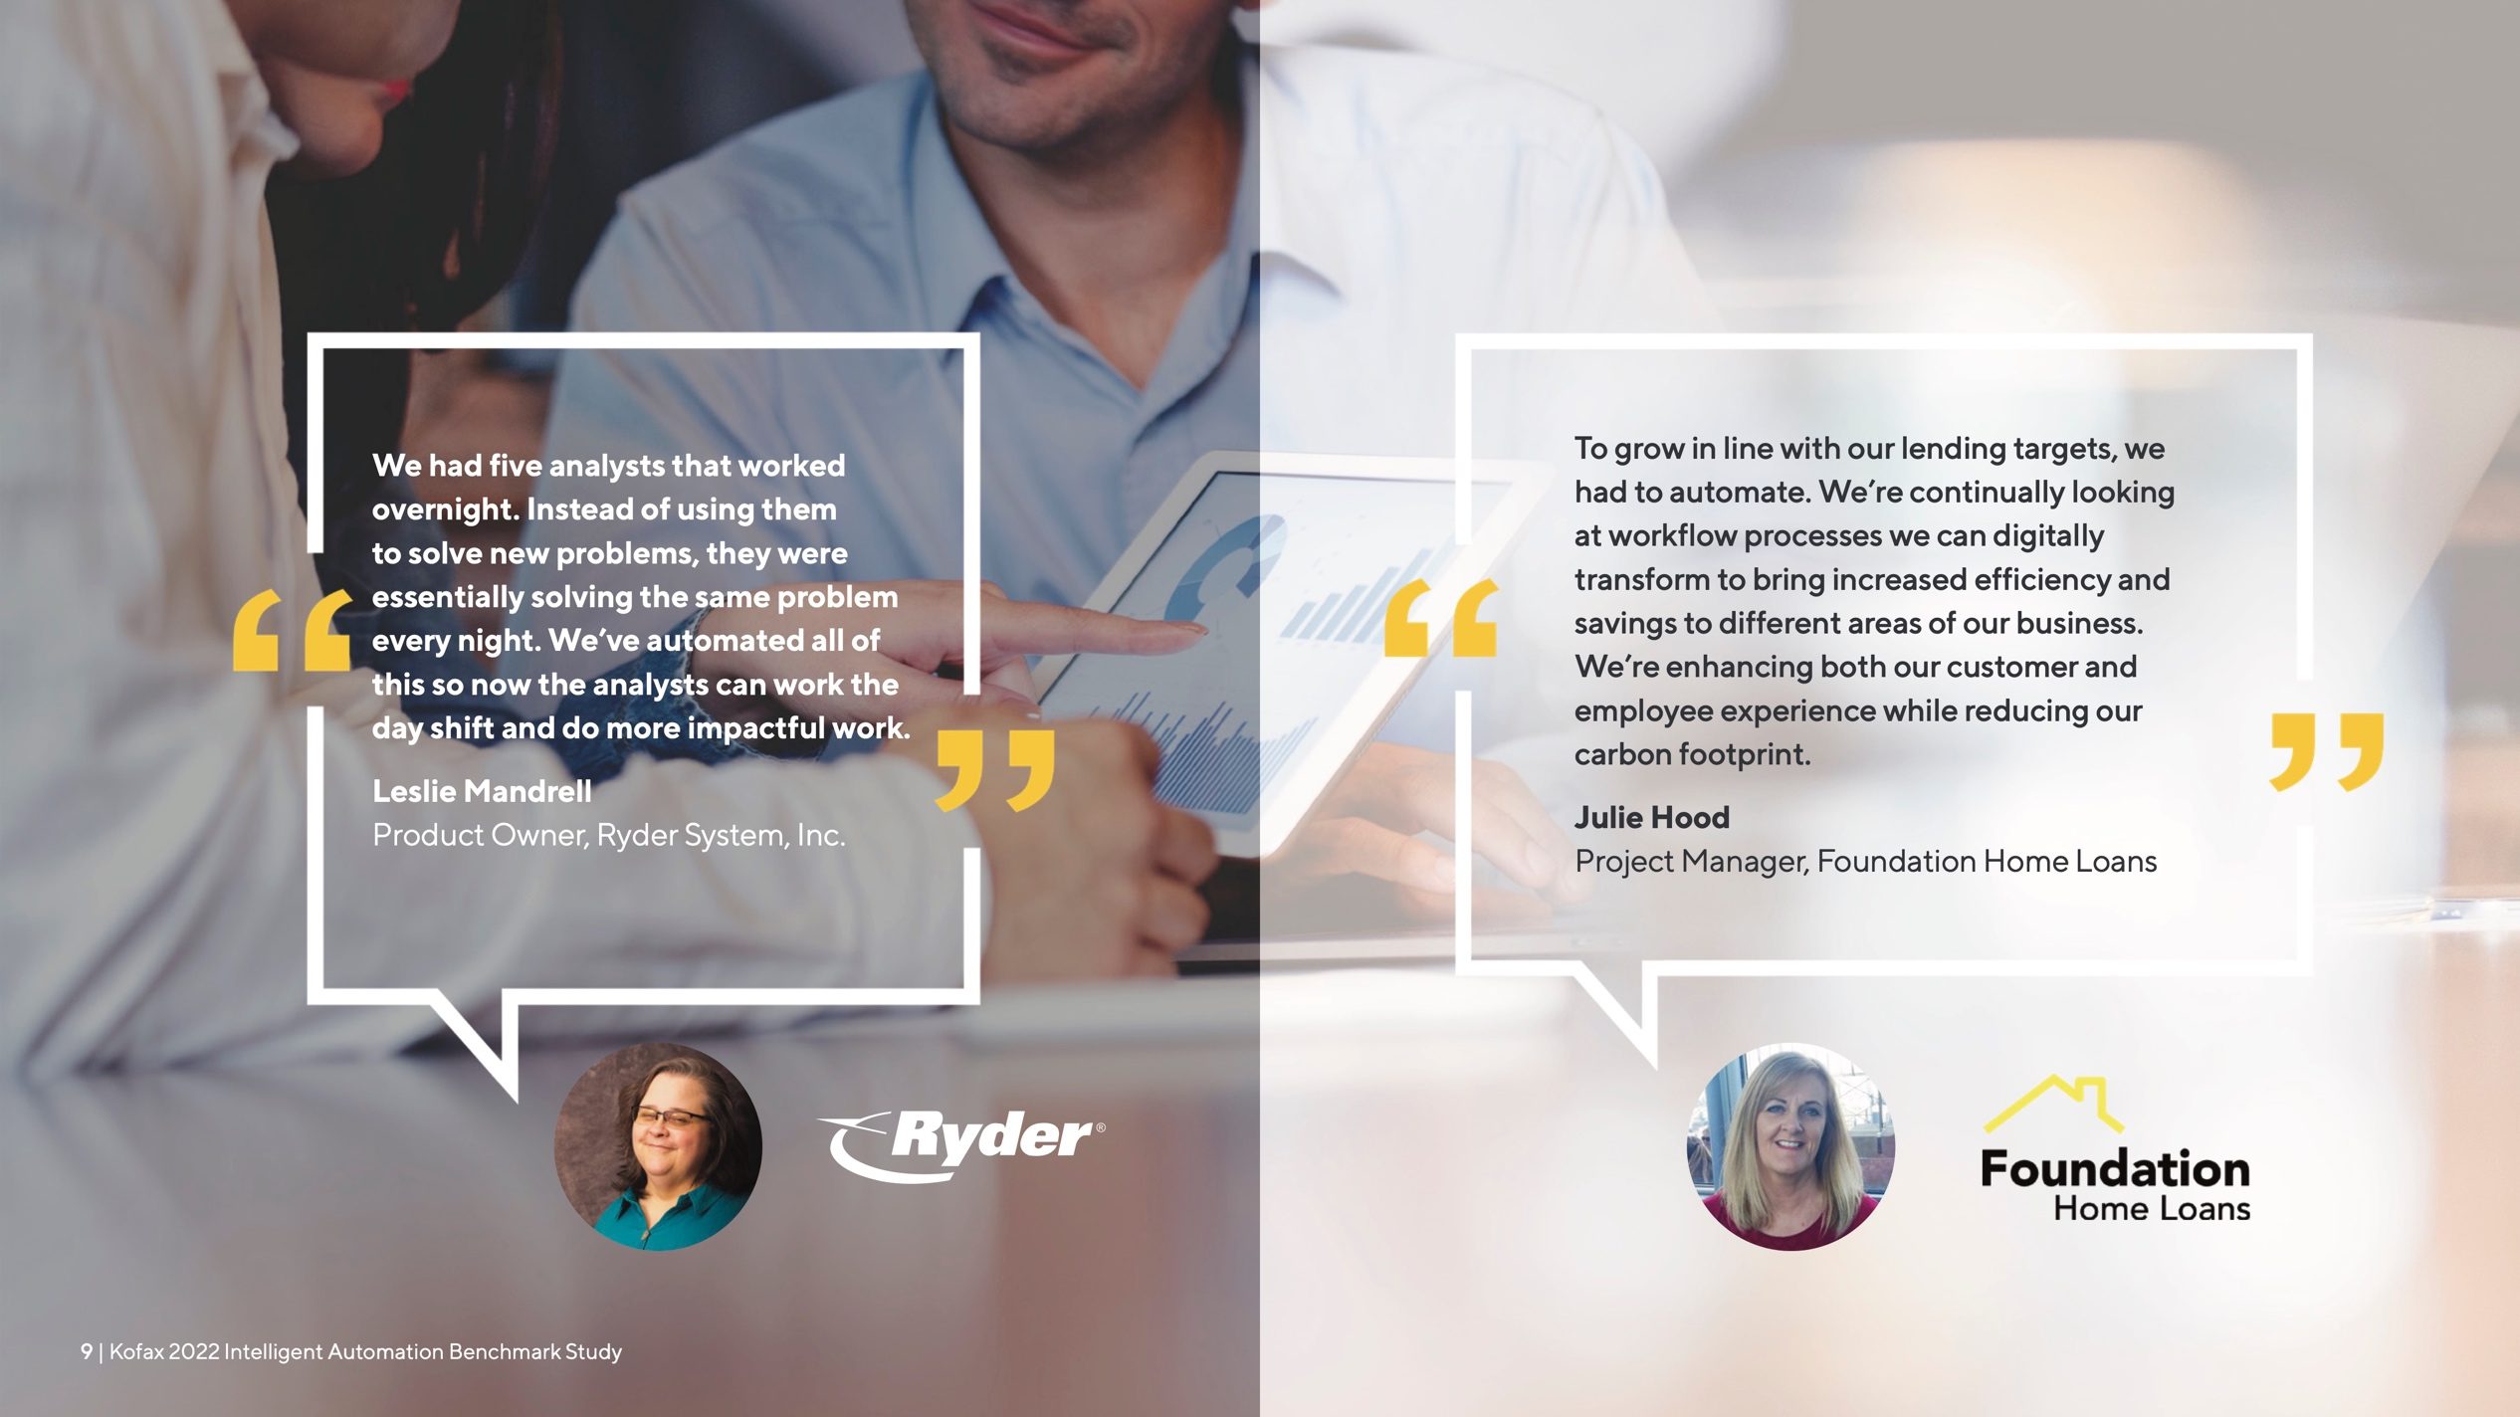

We had five analysts that worked overnight. Instead of using them to solve new problems, they were
essentially solving the same problem every night. We’ve automated all of this so now the analysts can work the day shift and do more impactful work.
Leslie Mandrell
Product Owner, Ryder System, Inc.
To grow in line with our lending targets, we had to automate. We’re continually looking at workflow processes we can digitally transform to bring increased efficiency and savings to different areas of our business.
We’re enhancing both our customer and employee experience while reducing our carbon footprint.
Julie Hood

Project Manager, Foundation Home Loans



- | Kofax 2022 Intelligent Automation Benchmark Study
9 | Kofax 2022 Intelligent Automation Benchmark Study

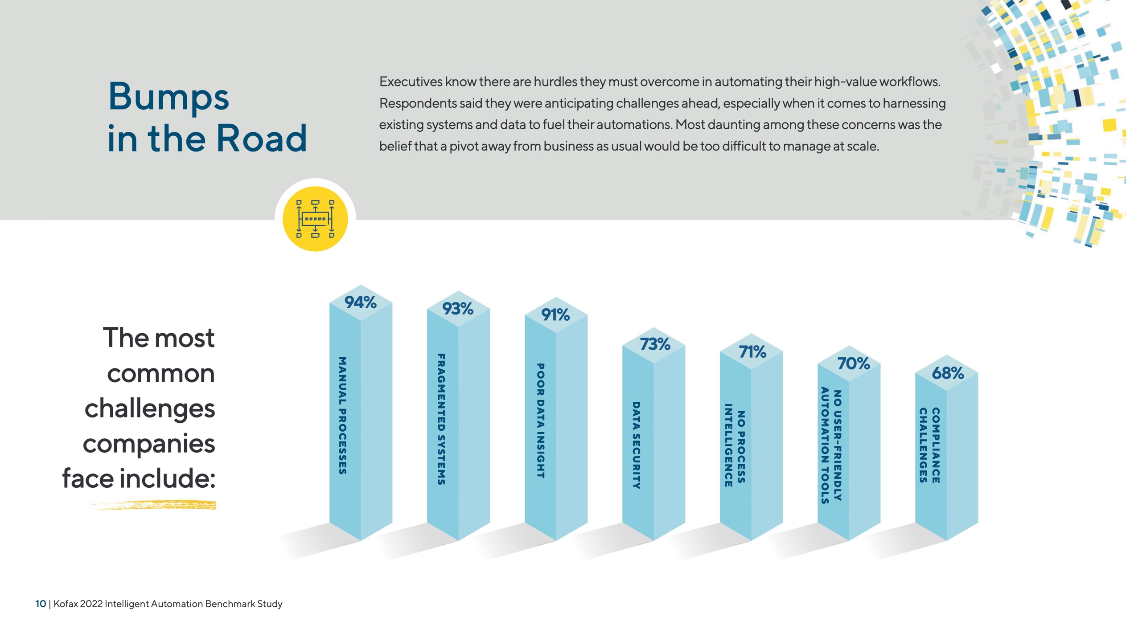

Bumps
in the Road

Executives know there are hurdles they must overcome in automating their high-value workflows. Respondents said they were anticipating challenges ahead, especially when it comes to harnessing existing systems and data to fuel their automations. Most daunting among these concerns was the belief that a pivot away from business as usual would be too difficult to manage at scale.

The most common challenges companies face include:
MANUAL PROCESSES

94% 93% 91%

73% 71%
POOR DATA INSIGHT

70% 68%
COMPLIANCE CHALLENGES
NO USER-FRIENDLY
AUTOMATION TOOLS
NO PROCESS INTELLIGENCE
DATA SECURITY



- | Kofax 2022 Intelligent Automation Benchmark Study
FRAGMENTED SYSTEMS




Our automation journey has taken a number of twists and turns. But what surprised us most has been how simple it has been to introduce quite a complex algorithm into the business to solve a problem that was persistent. We had no alternative other than to do something innovative.
Darren Wood

General Manager, Technology & Innovation and Acting Business Development Manager, Ron Finemore Transport

- | Kofax 2022 Intelligent Automation Benchmark Study
11 | Kofax 2022 Intelligent Automation Benchmark Study


12 | Kofax 2022 Intelligent Automation Benchmark Study
The DNA of
High-value Workflows
As they embark on this journey, executives are taking stock
of their high-priority workflows and identifying the tasks, data sources and routine procedures they believe are ready to be automated. Executives say there’s a common theme across these workflows—a certain “DNA” that all their strategic processes have in common.
12 | Kofax 2022 Intelligent Automation Benchmark Study
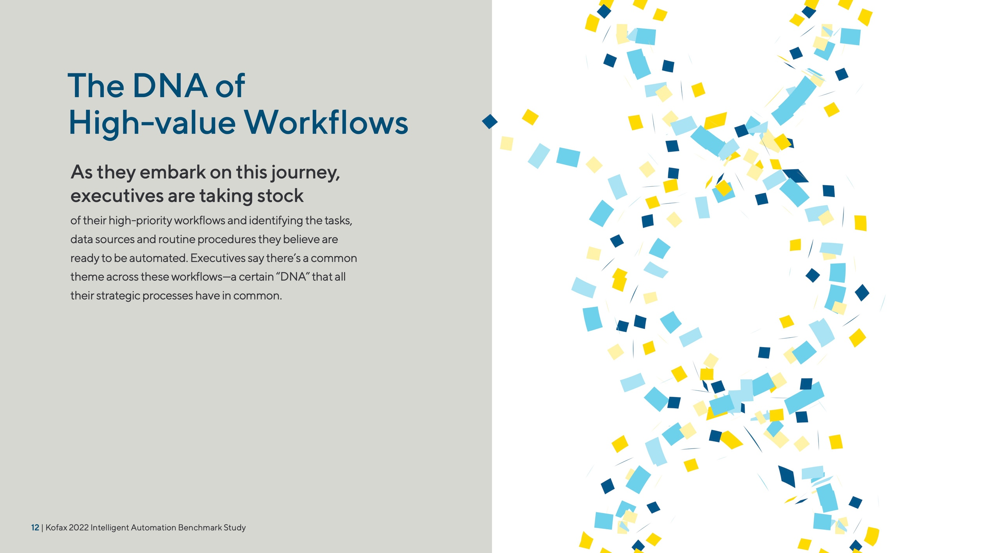


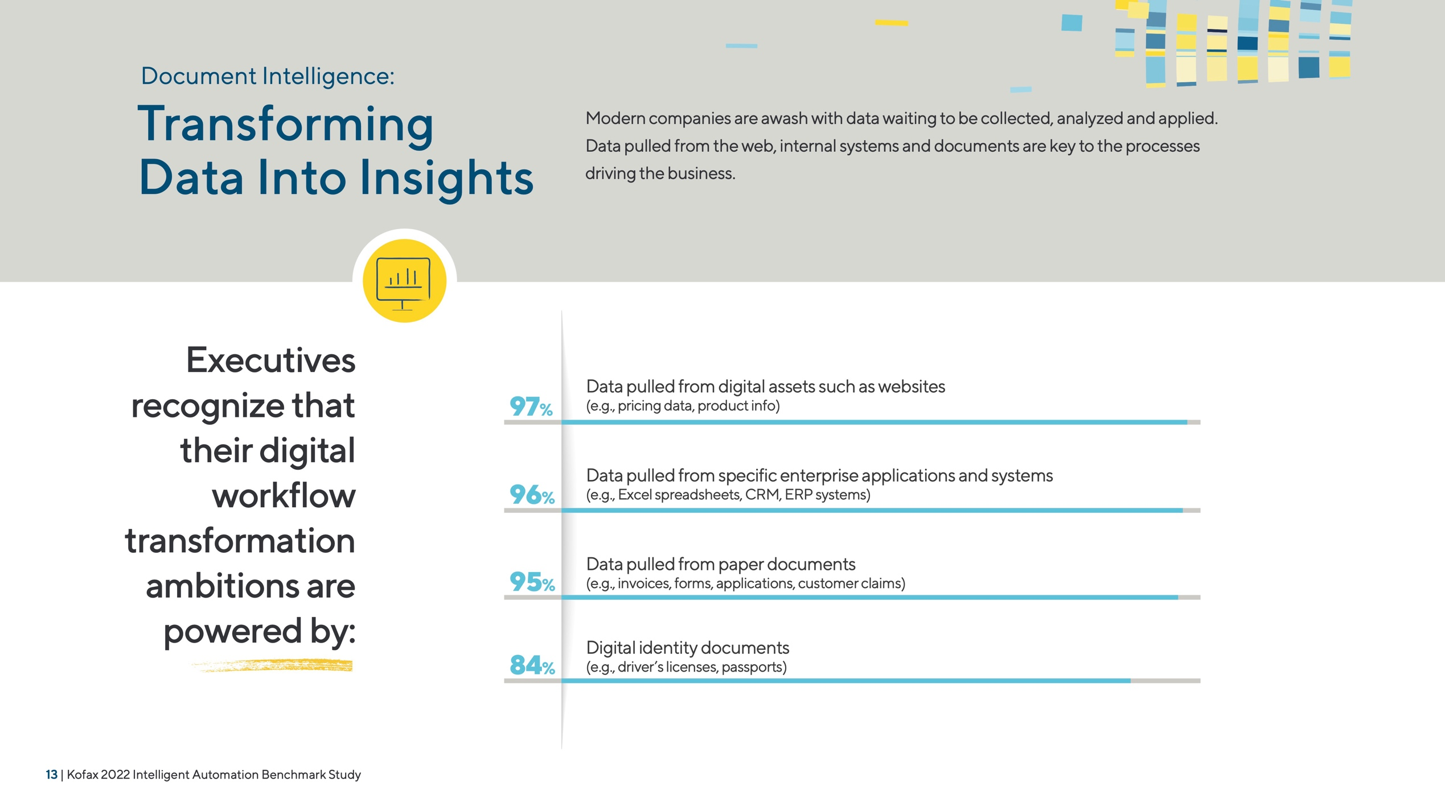

Document Intelligence:

Transforming Data Into Insights

Modern companies are awash with data waiting to be collected, analyzed and applied. Data pulled from the web, internal systems and documents are key to the processes driving the business.



Executives recognize that their digital workflow transformation ambitions are powered by:
Data pulled from digital assets such as websites
97% (e.g., pricing data, product info)
96% (e.g., Excel spreadsheets, CRM, ERP systems)
Data pulled from specific enterprise applications and systems
95% (e.g., invoices, forms, applications, customer claims)
Data pulled from paper documents
84% (e.g., driver’s licenses, passports)
Digital identity documents

- | Kofax 2022 Intelligent Automation Benchmark Study

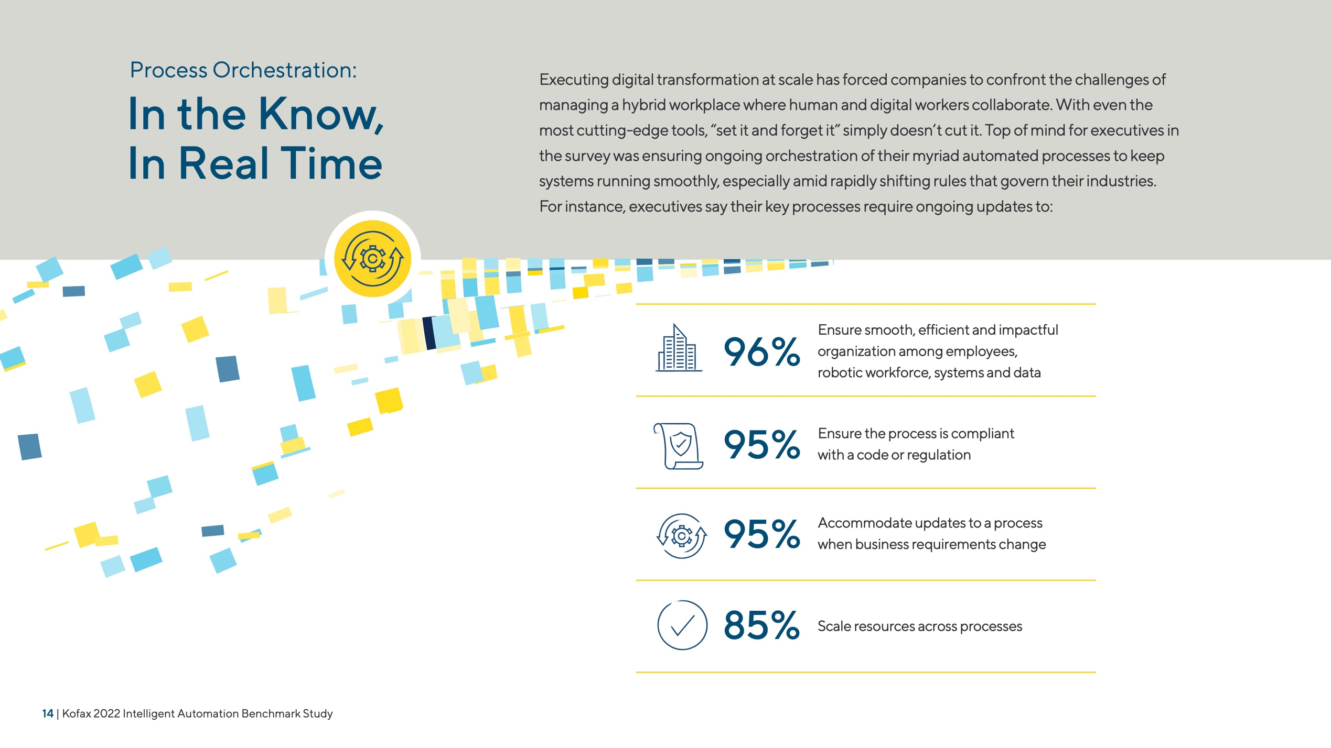

Process Orchestration: Executing digital transformation at scale has forced companies to confront the challenges of

In the Know, In Real Time
managing a hybrid workplace where human and digital workers collaborate. With even the most cutting-edge tools, “set it and forget it” simply doesn’t cut it. Top of mind for executives in the survey was ensuring ongoing orchestration of their myriad automated processes to keep systems running smoothly, especially amid rapidly shifting rules that govern their industries.
For instance, executives say their key processes require ongoing updates to:








- | Kofax 2022 Intelligent Automation Benchmark Study
96%

95%

95%

85%
Ensure smooth, efficient and impactful organization among employees, robotic workforce, systems and data

Ensure the process is compliant with a code or regulation

Accommodate updates to a process when business requirements change

Scale resources across processes

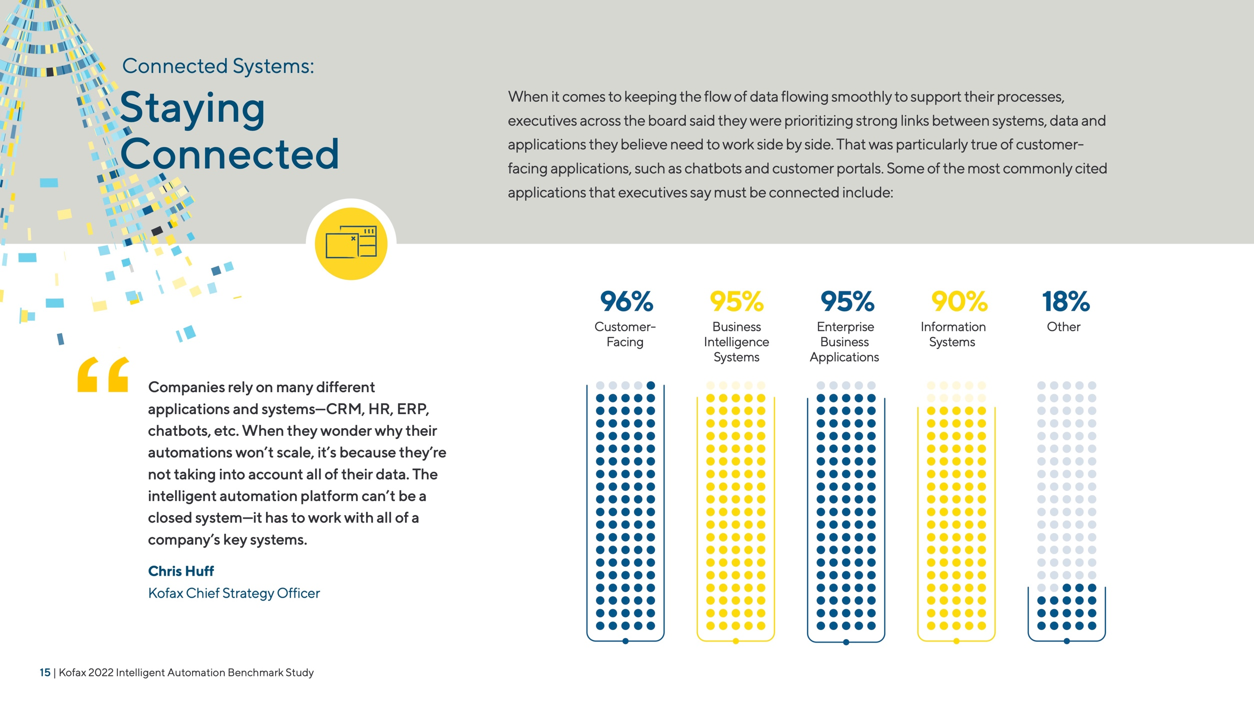

Connected Systems:

Staying Connected

When it comes to keeping the flow of data flowing smoothly to support their processes, executives across the board said they were prioritizing strong links between systems, data and applications they believe need to work side by side. That was particularly true of customer- facing applications, such as chatbots and customer portals. Some of the most commonly cited applications that executives say must be connected include:

96% 95% 95% 90% 18%



Companies rely on many different applications and systems—CRM, HR, ERP, chatbots, etc. When they wonder why their automations won’t scale, it’s because they’re not taking into account all of their data. The intelligent automation platform can’t be a closed system—it has to work with all of a company’s key systems.

Chris Huff
Kofax Chief Strategy Officer

- | Kofax 2022 Intelligent Automation Benchmark Study
Customer- Facing


Business Intelligence Systems

Enterprise Business Applications

Information Systems


Other





We have learned not to automate everything. Every process has parts requiring a person to be involved. Solving process and automation problems means making sure we have people interacting seamlessly with digital workers and getting really good at handing off responsibilities between the two.
Robert Duber
Process Automation Manager, University Hospitals

- | Kofax 2022 Intelligent Automation Benchmark Study
16 | Kofax 2022 Intelligent Automation Benchmark Study

Reaping
the Rewards

Executives expect their forays into digital transformation to pay dividends down the line. Increased efficiency was the most frequently predicted outcome, alongside lower costs, higher revenues and better results with customers.

By digitally transforming their high-value workflows, executives expect to:

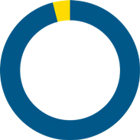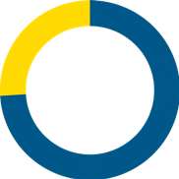Operate more efficiently

96%

74%

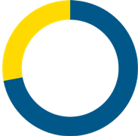Significantly reduce costs

94%

72%

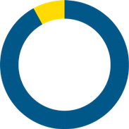Generate higher revenues

92%

72%

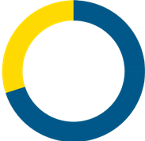Attract new customers

92%

70%

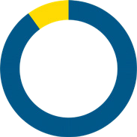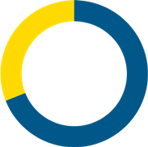Retain existing customers

90%

69%



- | Kofax 2022 Intelligent Automation Benchmark Study
Improve customer satisfaction
Achieve competitive advantage
Help employees do more with less
Eliminate dull, repetitive work
Improve relationships with outside vendors



As the size of our business increases, processes have to be automated so we can keep up our high standards of service.
Julie Hood
Project Manager, Foundation Home Loans

- | Kofax 2022 Intelligent Automation Benchmark Study
18 | Kofax 2022 Intelligent Automation Benchmark Study

Room To Grow

The shift toward digital transformation clearly has a long way to go, as executives said many of their top-priority workflows were still partially or entirely manual. None of the respondents has fully
automated any of the high-value workflows they report as being critical to their digital transformations.







To accelerate the pace of automation, organizations need to move from point solutions that automate individual workflows to a platform approach that ties them all together.
M A N U A L | Accounts payable automatio | n 17 % |  | 28 % |  |  | PA R T I A L LY M A N U A L
M A N U A L | Bank statement processin | g 16 % |  | 25 % |  |  | PA R T I A L LY M A N U A L
M A N U A L | Claims processing 2 | 6 % |  | 29 % |  |  | PA R T I A L LY M A N U A L
M A N U A L | Digital mailroom | 21 % |  | 25 % |  |  | PA R T I A L LY M A N U A L
M A N U A L | Document security management | 19 % |  | 30 % |  |  | PA R T I A L LY M A N U A L
M A N U A L | Invoice processin | g 17 % |  | 26 % |  |  | PA R T I A L LY M A N U A L
M A N U A L | Onboarding | 24 % |  | 31 % |  |  | PA R T I A L LY M A N U A L
M A N U A L | Other proprietary workflows | 18 % |  | 33 % |  |  | PA R T I A L LY M A N U A L
M A N U A L | Transaction processing | 22 % |  | 24 % |  |  | PA R T I A L LY M A N U A L

Chris Huff
Kofax Chief Strategy Officer

- | Kofax 2022 Intelligent Automation Benchmark Study

What’s Your Tomorrow?

Organizations are focused overwhelmingly on ensuring business continuity and maintaining a competitive advantage.




Chris Huff
Kofax Chief Strategy Officer

To do this, they’re
fast-tracking automating their mission-critical business workflows.

When almost anything can be automated, executives are prioritizing the high-value operational, customer and financial processes that have the biggest impact on growing revenues, streamlining operations and improving customer and employee experience. Executives face common challenges when automating these workflows— from fragmented systems and poor data insight, to lack of process insight and inability to manage automations at scale. To overcome this, their intelligent automation platform must excel at
document intelligence to ingest, classify and extract unstructured information and transform it to fuel automation. It must be able to connect disparate business systems like applications, chatbots, mobile and web. And it should deliver strong process orchestration to manage the digital and human workforce
at scale. Focused on the right priorities and armed with an intelligent automation platform that’s up to the task, enterprises are achieving their automation ambitions: improving customer experiences, running their businesses more effectively and efficiently, ensuring compliance and making their employees’ work lives happier and more
fulfilling. Kofax’s 2022 Intelligent Automation Benchmark Survey was designed to give you insight into how some of the most innovative companies in the world are driving their businesses with automation success. Whether you are just starting or have a robust automation program in your organization, we hope this study gives you new insights into how automation might help
your business. At Kofax, our mission is to help our customers work like tomorrow, today. And we hope this report helps you answer the question:
“What’s your tomorrow?”



- | Kofax 2022 Intelligent Automation Benchmark Study

Respondent Demographics

Location
Title
Industry

Response No. %
Response No. %
Response No. %

Australia 72 9.0
Canada 90 11.3
France 68 8.5
C-level executive (e.g., CEO, CIO)284 35.5
Advertising and/or marketing 30 3.8
Business or professional services 50 6.3
Agriculture, food and/or beverage 30 3.8
Chemicals and/or metals 40 5.0

Director (in charge of a team of
Germany 68 8.5
VP/SVP/EVP/MD (in charge of one/ several large departments)
172
21.5
Hong Kong65 |  | 8.1 |  | managers and high-level co | ntributors) |  |  | Construction | 30 | 3.8
Japan | 65 | 8.1 |  | Total | 800 | 100 |  | Consumer product goods and/or manufacturing45 |  | 5.6
Singapore65 |  | 8.1 |  |  |  |  |  | Consumer services | 30 | 3.8

344 43.0

United Kingdom71 8.9
100
800
Total
22.0
United States176
Sweden 60 7.5

Company Revenue

Department

Response | No. | %
Finance/accounting | 130 | 16.3
Human resources/training130 |  | 16.3
IT/IS/technology | 150 | 18.8
Marketing/advertising | 120 | 15.0

Education and/or nonprofits 40 5.0
Electronics 35 4.4

Energy, utilities and/or waste management50 |  | 6.3
Financial services and/or insurance | 50 | 6.3
Government/public sector | 40 | 5.0
Healthcare | 50 | 6.3
Legal services | 20 | 2.5
Manufacturing and materials 70 8.8
 |  |  |  | Operations | 150 | 18.8
Response | No. | % |  |  |  |  |  | Media and/or leisure | 30 | 3.8
$500m to $1bn400 |  | 50.0 |  |  |  |  |  | Retail | 40 | 5.0
$1bn to $5bn225 |  | 28.1 |  |  |  |  |  | Technology and/or technology services30 |  | 3.8
$5bn or more175 |  | 21.9 |  |  |  |  |  | Telecommunications services | 30 | 3.8
Total | 800 | 100 |  |  |  |  |  | Transportation and logistics | 30 | 3.8
 |  |  |  |  |  |  |  | Travel and hospitality | 30 | 3.8
 |  |  |  |  |  |  |  | Total | 800 | 100

Sales | 120 | 15.0
Total | 800 | 100

- | Kofax 2022 Intelligent Automation Benchmark Study

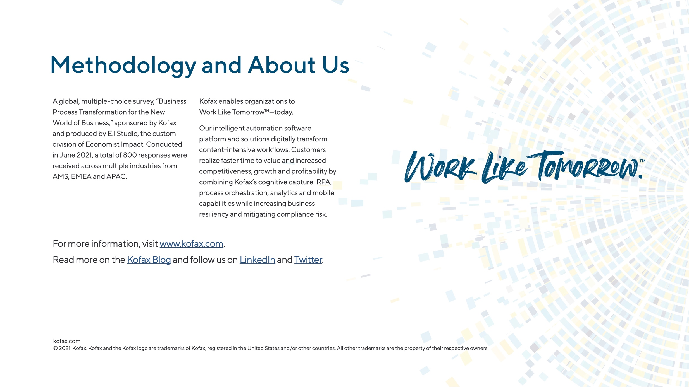
(Source: Produced by E.I Studio, the custom division of Economist Impact)

