
CFOLC TOOLS LIBRARY
2022 Best & Worst states for Business Survey of CEOs

Where would you want to open new facilities or relocate your firm in this period of high taxes, over-regulation and growing labor costs?

Check out our ranking to help your strategic planners aim for areas with high profit and low expense environments.

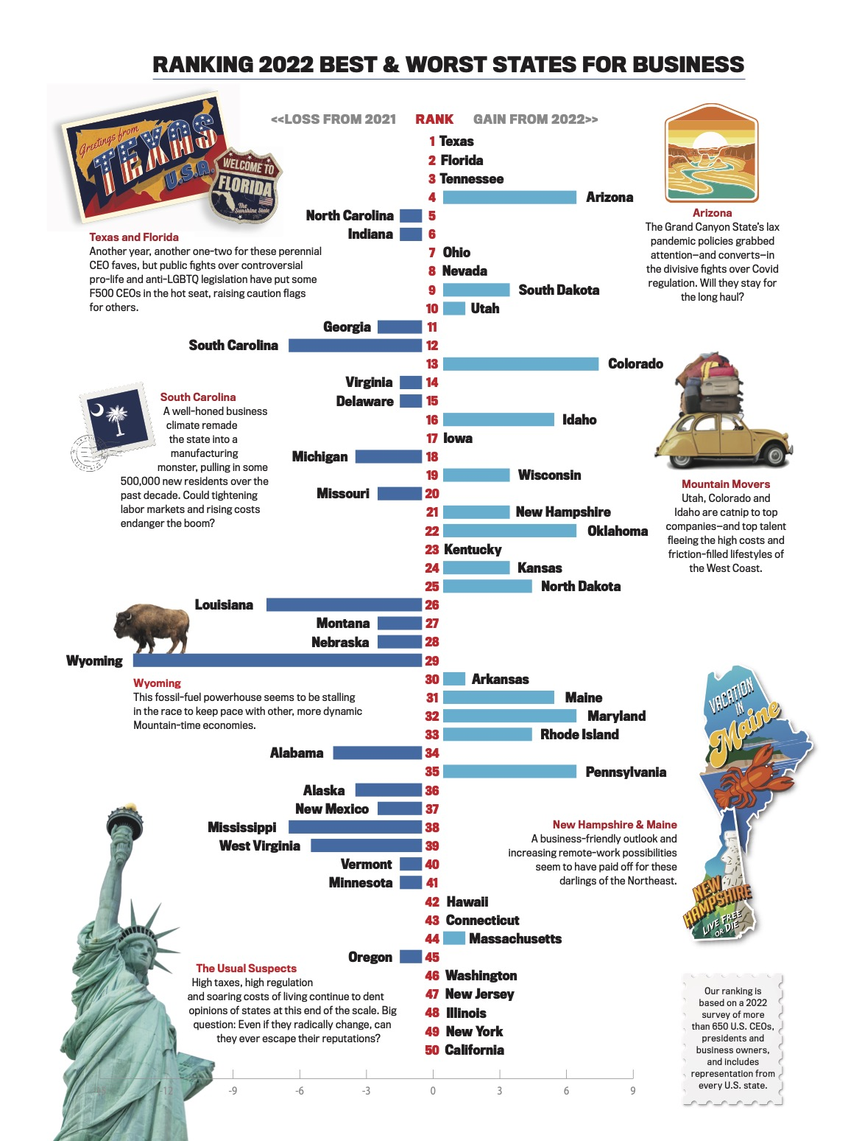

In what’s become an annual rite of spring for our Best & Worst States for Business survey of CEOs, Texas and Florida held on to their No. 1 and No. 2 spots this year, continuing their long-running lock on the top of the rankings.
Based on polling of nearly 700 CEOs and business owners from every U.S. state, conducted in January and February 2022, the Lone Star State placed No. 1 again, as it has every year since Chief Executive began the compiling the list in 2001. Their combination of a fast-growth population and a low-tax, low-regulation business climate is proven catnip for companies.
It’s a position that seems unlikely to change, even as Governor Greg Abbott has stressed some corporate sensibilities in recent weeks by snarling supply chains with an order for state inspection of commercial trucks coming from Mexico, looking to stop the flow of illegal immigrants and drugs. Abbott also has assumed a high profile in the growing national controversy over new abortion restrictions that began with a law in Texas.
The state’s faltering electrical grid resulted in a similar tsunami of criticism—even worse in business circles, including a rare knuckle-rap from new Austin resident Elon Musk in early 2021—but that did little to chill the state’s reputation or ranking among CEOs.

Complete Coverage: Best & Worst States For Business 2022 >
Meanwhile, Florida has solidified its hold on the No. 2 position in the Chief Executive rankings with a consistently business-friendly approach under Governor Ron DeSantis that crested during the past couple of years with his hands-off approach to Covid shutdowns.
Yet, DeSantis’s high-profile battle with Walt Disney CEO Bob Chapek over references to sexual orientation and gender identity in Florida’s elementary school curriculum, labeled “Don’t Say Gay” by opponents (which came to a head after this year’s Best & Worst States polling was conducted), threatens one of the coziest relationships between a state and a big company anywhere in the country.
Will the battle raise alarms with other CEOs who’ve come to count on Florida as a home for their companies? That’s going to be an open question in the months to come—though likely more for high-profile Fortune 500 CEOs such as Chapek, under increasing pressure by progressives and conservatives alike to take stands on social issues, than for CEOs of mid-market manufacturing and service companies, who still make most of the siting decisions in this country. If history is a guide, they may not take as much notice of the extended political theatrics by DeSantis, who is said to have presidential aspirations.
Texas has enjoyed an era of stunning growth based on a broadening of its economy to automobile production, digital-technology development and shared services as well as the traditional base in oil, gas and refining. And last fall, Samsung announced its investment of $17.1 billion to construct a microchip factory outside Austin.
Similarly, Florida and Tennessee (holding at No. 3) have welcomed continuing streams of new corporate investments, such as Ford’s recent multi-billion-dollar commitment to Tennessee to build electric vehicles there. Arizona climbed six spots this year, to No. 4 in the ranking, thanks in part to the most laissez-faire pandemic-shutdown policies in the West.
“There’s a big spread across the Sun Belt from Raleigh to Charlotte to Tampa and Jacksonville, and the big metro areas of Texas, on to Phoenix that are all in various respects growing fast,” said Cullum Clark, director of the Bush Institute-SMU Economic Growth Initiative. “It’s a distinctive model.”

Midwest & The Rest
Amid a resurgence of high-profile economic development projects throughout the nation’s industrial heartland, Indiana, No. 6 overall, remained the top-ranked state in the Midwest. Even before Intel’s promise to start with a new $20-billion microchip plant in No. 7 Ohio, the two states continued to lead a relentless, years-long rise in the rankings by Midwestern states including Iowa, Michigan, Wisconsin and Missouri.
Utah, No. 10 overall, was ranked the top state in the Mountain West by surveyed CEOs. Delaware, No. 15, was the top-ranked state in the Mid-Atlantic region, and New Hampshire, No. 21, the top state in the Northeast.
Other significant movers in the 2022 Best & Worst States for Business included Colorado, which raced ahead by seven spots to No. 13; and Idaho, which rose by five spots to No. 16. Each of these mountainous Western states has built a reputation as a lifestyle haven for tech workers, who increasingly have been unleashed from Silicon Valley and other Pacific Coast states by the remote-work revolution.
States at the bottom of the list continued to suffer from reputations for high taxes, regulation and costs of living, with Washington at No. 46, followed by New Jersey, Illinois, New York and California, all unchanged in their rankings from previous years. Despite some of the nation’s top talent pools and education systems, it will take a true revolution in their tax and regulatory structures to gain ground with CEOs—and move up from the basement.

(Source: Chief Executive Group)

