
CFO Salaries by Company Revenue
CFOLC TOOLS LIBRARY



2022 CFO Salary Guide
The Wall Street Journal published a list of the five highest-paid CFO’s late last year. The list cited high power executives, including Safra Catz at Oracle Corp. ($108.3 million), Ruth M. Porat at Alphabet Inc. ($47.3 million), Luca Maestri at Apple Inc. ($26.5 million), Michael Fleisher at Wayfair Inc. ($23.6 million), and John P. Nallen at 21st Century Fox Inc. ($20.8 million). These numbers are a far cry from the national average CFO salary. According to Payscale, the average CFO will receive a salary of $133,000.00.
Regardless of the total dollar amount, however, we must delineate salary from total compensation. As the complexities of company management expand, so too do the kinds of rewards. Total compensation is an umbrella term that encompasses both a base salary as well as additional benefits, bonuses, stock shares (in publicly traded companies), and perks.
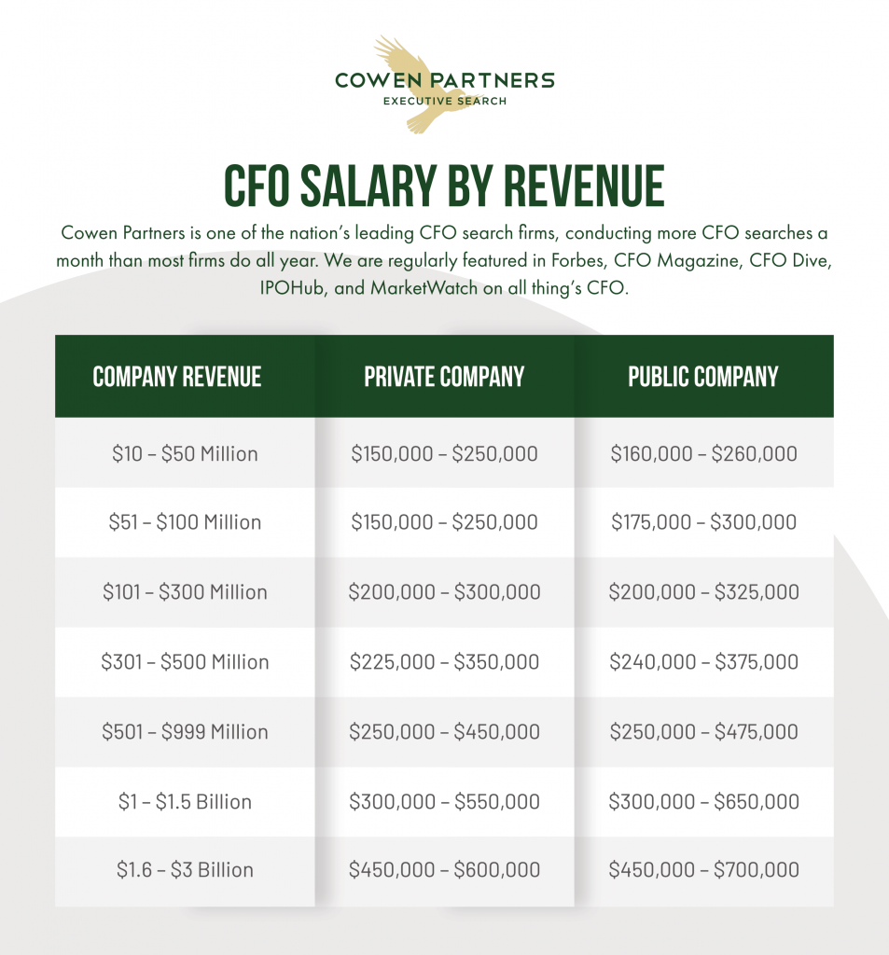
Average CFO Salary

